**KWORUS SECONDARY SCHOOL**

**P.O BOX 121 KAPCHORWA-KWEEN.**

[**TEL:0777253593/0777146352**](TEL:0777253593/0777146352) **or Email:kworusss@gmail.com**

**EOT ONE S.1 GEOGRAPHY 2024**

**Instructions: Attempt this item. TIME 1hour**

**Item 1**

The environment is the man’s surrounding. In East Africa man has set up industries, reared large herds of cattle, practiced crop cultivation on highland areas, practiced deforestation, carried out mining among others in order to sustain a livelihood. These activities have had impacts on the environment and man himself. A section of the people of East Africa are concerned

**Support material**

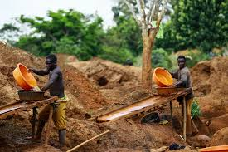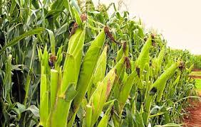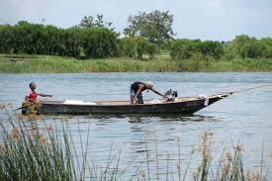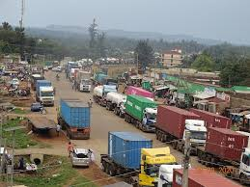

**Task**. Organize a sensitization message of 150-200 words you will present at a meeting.

**End**

**……………….………………………………………………………………………………………………………………**

**……………….………………………………………………………………………………………………………………**

**……………….………………………………………………………………………………………………………………**

**……………….………………………………………………………………………………………………………………**

**……………….………………………………………………………………………………………………………………**

**……………….………………………………………………………………………………………………………………**

**……………….………………………………………………………………………………………………………………**

**……………….………………………………………………………………………………………………………………**

**……………….………………………………………………………………………………………………………………**

**……………….………………………………………………………………………………………………………………**

**……………….………………………………………………………………………………………………………………**

**……………….………………………………………………………………………………………………………………**

**……………….………………………………………………………………………………………………………………**

**……………….………………………………………………………………………………………………………………**

**……………….………………………………………………………………………………………………………………**

**……………….………………………………………………………………………………………………………………**

**……………….………………………………………………………………………………………………………………**

**……………….………………………………………………………………………………………………………………**

**……………….………………………………………………………………………………………………………………**

**……………….………………………………………………………………………………………………………………**

**……………….………………………………………………………………………………………………………………**

**……………….………………………………………………………………………………………………………………**

**……………….………………………………………………………………………………………………………………**

**……………….………………………………………………………………………………………………………………**

**……………….………………………………………………………………………………………………………………**

**……………….………………………………………………………………………………………………………………**

**……………….………………………………………………………………………………………………………………**

**……………….………………………………………………………………………………………………………………**

**……………….………………………………………………………………………………………………………………**

**……………….………………………………………………………………………………………………………………**

**……………….………………………………………………………………………………………………………………**

**………………………………………………………………………………………………………………………………**